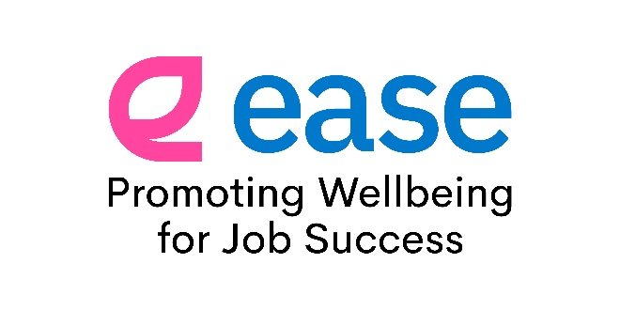

EASE App Launch

Communications Pack:

What is EASE?
EASE is a mobile app designed to support disabled people in employment.
It connects users to tailored support services, resources, and guidance to help them:
- Stay well at work
- Overcome challenges
- Progress in their careers
By answering a few simple questions, users receive a personalised experience with:
- Relevant local services
- Wellbeing resources
- Motivational content
- Career development tips
The app is not only for when things are difficult - it's also designed to help users stay on track, motivated, and thriving in their roles.
EASE has been made possible via the Scottish Government funding administered by The Health and Social Care Alliance Scotland (the ALLIANCE). The Self Management Fund for Scotland aims to empower people living with long term conditions, disabled people and unpaid carers to take control their health, care and wellbeing.
Over the past two years, we have worked with developers and the EASE App Delivery Team - a group of SUSE members and partners who bring both expertise and lived experience - to turn this idea into a fully functioning app, ensuring it is accessible and that resources are practical and relevant.
We’re delighted to announce that the EASE App is now available to download on Google Play and the Apple App Store.

Aim of the Communications Pack
This communications pack is designed to:
- Raise awareness of the EASE App
- Clearly explain the app’s benefits and purpose
- Encourage downloads and adoption
- Provide ready-made content for multiple channels

How you can support:
We are running promotions across social media and news on the SUSE website and e-bulletin, as well as communications with our wider network.
We have put together messages, graphics and links which you are welcome to use on your social media platforms and newsletters.
Further information can be found on the SUSE website: EASE App
If you require any further information please contact Fiona Walker, Marketing and Communication Manager at fiona@susescotland.scot
Below you will find suggested content for:
- Newsletters / blogs
- Social media – including various message styles and lengths
- Email and WhatsApp – to directly inform people you think may benefit from using the app
- Links to SUSE socials
- Graphics and alt text (jpegs attached to email).

Ready to Use Messages

Suggested Newsletter / Blog Content
Short Version:
EASE App Now Available!
SUSE (Scottish Union of Supported Employment) are excited to announce that their EASE App is now available to download on Google Play and the Apple App Store.
EASE is designed to support disabled people in employment, helping you stay well, overcome challenges and succeed in your role.
By answering a few simple questions, the app provides personalised support and links you to relevant services and resources in your area.
It also offers motivational content, wellbeing tips and career advice to help you stay on track - even when things are going well.
👉 Download the EASE App today and take the next step in your employment journey. Search ‘suse ease app’ on your app store.

Longer Version:
Introducing the EASE App – Supporting You at Work
We’re delighted to announce the launch of the EASE App, now available on Google Play and the Apple App Store.
Developed by SUSE (Scottish Union of Supported Employment), EASE has been designed specifically for disabled people in employment, providing easy access to tailored support, guidance and resources to help you thrive at work.
How it works:
- Identify the areas that matter most to you in your current role
- Answer a few simple questions
- Receive personalised support based on your needs
If the app identifies that you may benefit from additional support, it will provide links to relevant services and information - tailored to your location and individual circumstances.
But EASE isn’t just for when things are difficult. It also helps you:
- Stay motivated
- Maintain your wellbeing
- Access career progression tips
- Build your own personalised resource bank
With regular updates, reminders and expert guidance, EASE is designed to support you every step of the way.
Download the EASE App today and take control of your wellbeing and career.
Available on Google Play and the Apple App Store – search ‘suse ease app’.

Social Media Content
Very Short:
The EASE App is here!
Download now and access support, wellbeing tools and career tips.
Available on Google Play & Apple App Store.

Short Posts:
Option 1
The EASE App is now live! 🎉
Developed by SUSE to support disabled people in employment - with personalised resources, wellbeing support, and career tips.
Download today on Google Play and Apple App Store.
Option 2
Need support at work? Or just want to stay on track?
The EASE App, brought to you by SUSE, connects you to tailored support and resources.
Download now on Google Play and Apple App Store.

Medium-Length Posts:
Option 1
We’re excited let you know about the EASE App!
Designed by SUSE for disabled people in employment, EASE helps you:
✅ Look after your wellbeing at work
✅ Access personalised support
✅ Find relevant services in your area
✅ Stay motivated and progress your career
Download now on Google Play and the Apple App Store – search: suse ease app.

Option 2
Introducing EASE - your support companion at work brought to you by SUSE.
Whether you’re facing challenges or thriving in your role, EASE provides:
✔ Tailored resources
✔ Wellbeing support
✔ Career development tips
📲 Available now - download today on Google Play and the Apple App Store! Search: suse ease app.

Longer / LinkedIn Style Post:
We’re excited to let you know about the EASE App from SUSE.
EASE is designed to support disabled people in employment, helping individuals stay well at work, access the right support, and succeed in their careers.
By answering a few simple questions, users receive personalised guidance and connections to relevant local services. The app also provides wellbeing resources, motivational content, and career progression tips.
Importantly, EASE isn’t just for challenges - it’s there to help users stay on track and continue thriving.
📲 Download the EASE App now on Google Play and the Apple App Store. Search: suse ease app.

Email version for Job Coaches/Service Providers to send to Clients
Hello,
There is a new app called EASE that you can download for free. It is now available on the Google Play Store and Apple App Store.
The EASE app is made for people who are working. It can help you stay motivated and do well in your job. But you’ll also find tips and advice if you’re looking for a job.
What the app does
- Asks you to create your profile
- Asks a few simple questions about your work
- Helps you see what is going well
- Shows you support if you need help
The app will suggest useful services and information that are right for you and where you live.
It can also help you
- Look after your wellbeing
- Stay motivated
- Get tips to grow in your job
- Save helpful information to look at later
You can use the app any time - not just when things are difficult.
Download the EASE app today and give it a try. In your app store, search: suse ease app. If you need help downloading it, please let me know.

WhatsApp Version
Hi 😊
There’s a new free app called EASE that can help you at work. It can help you:
✅ Stay well
✅ Get support if you need it
✅ Find useful services near you
✅ Get tips for your job and career
It only takes a few simple questions to get started, and it gives support that’s right for you 👍
You can download it now on the Google Play Store or Apple App Store. Let me know if you’d like help downloading it!

Please use the following links and hashtags:
#EASEApp #EmploymentSupport #WellbeingInWork
LinkedIn: @Scottish Union of Supported Employment
Facebook: @SUSE Scotland

Graphics
Logos:
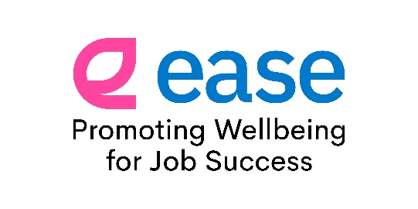
Alt text: The logo has the word ease written in lower case, bright blue, sans serif font for a friendly appearance. Next to the e is the brand icon, which is an e, with the top section shaped in an oval pointing up past the word ease. It has a leaf-like appearance and is pink. Underneath are the words Promoting Wellbeing for Job Success.
Reduced character version: ease logo, the word ease is written in lower case, blue font. Next to the e is the brand icon. It is an e with a leaf-like appearance and is pink. Underneath are the words Promoting Wellbeing for Job Success.
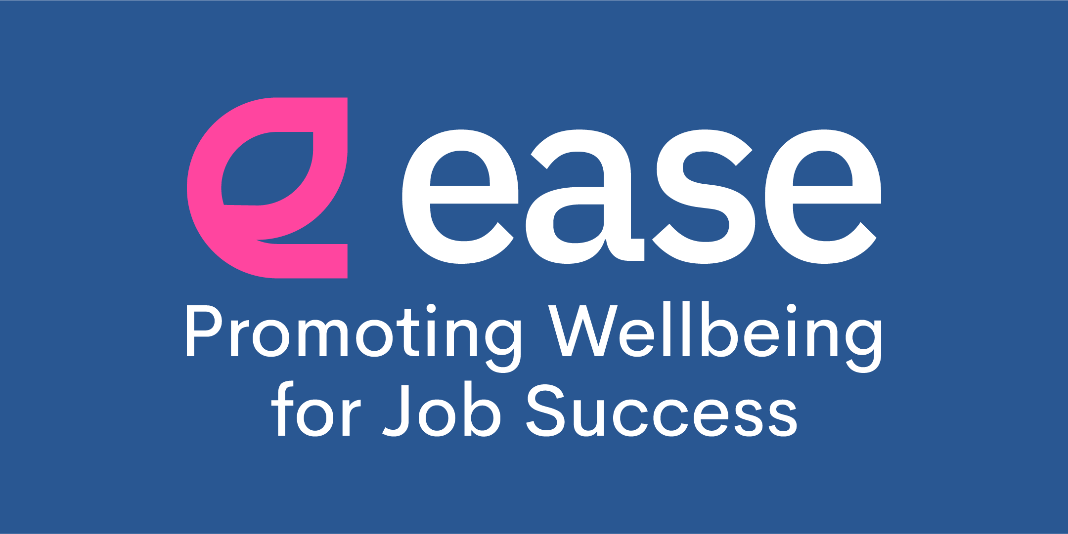
Alt text: The logo has a bright blue background with the word ease written in lower case, white, sans serif font for a friendly appearance. Next to the e is the brand icon, which is an e, with the top section shaped in an oval pointing up past the word ease. It has a leaf-like appearance and is pink. Underneath are the words Promoting Wellbeing for Job Success.
Reduced character version: ease logo, the word ease is written in lower case, white font. Next to the e is the brand icon. It is an e with a leaf-like appearance and is pink. Underneath are the words Promoting Wellbeing for Job Success.

Social Media images:
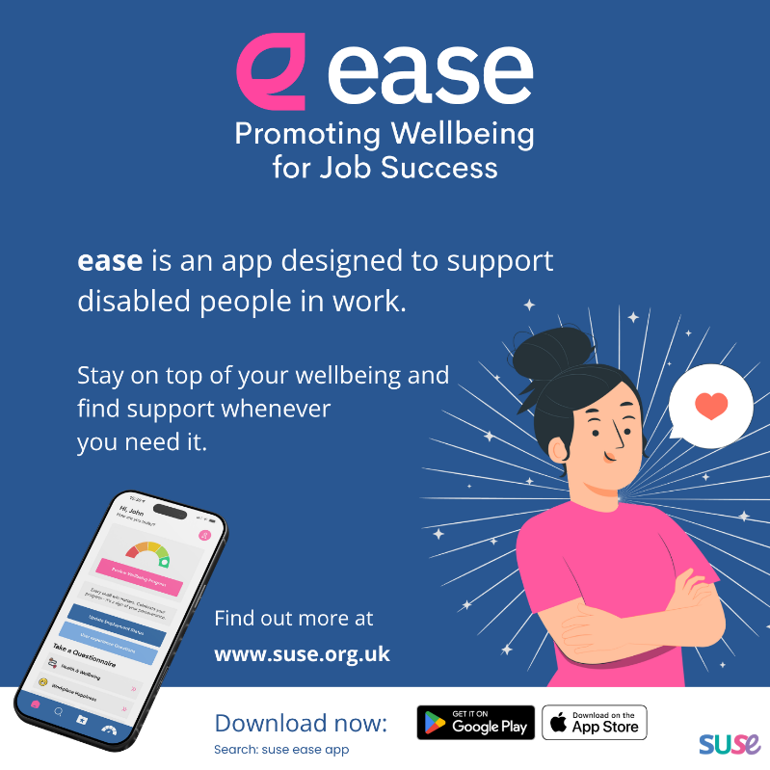
Alt text: Ease promoting wellbeing for job success. Ease is an app designed to support disabled people in work. Stay on top of your wellbeing and find support whenever you need it. Find out more at www.suse.org.uk and download now. Get it on Google Play and the Apple App Store. Search suse ease app. There are two images, one of a mobile phone with the screen showing the ease app, the other is an illustration of a person smiling with a speech bubble with a love heart in it.
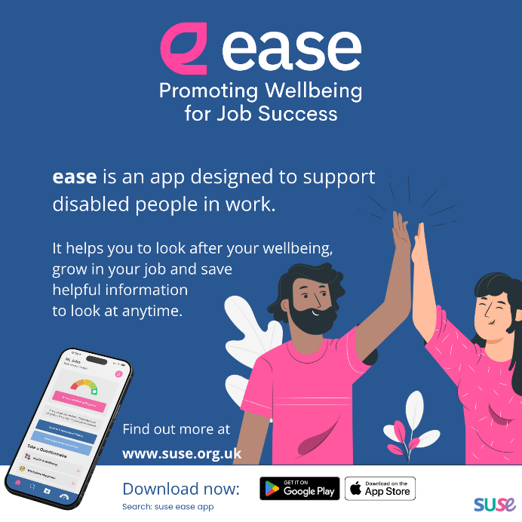
Alt text: Ease promoting wellbeing for job success. Ease is an app designed to support disabled people in work. It helps you to look after your wellbeing, grow in your job and save helpful information to look at anytime. Find out more at www.suse.org.uk and download now. Get it on Google Play and the Apple App Store. Search suse ease app. There are two images, one of a mobile phone with the screen showing the ease app, the other is an illustration of two people giving a high five.
A4 Flyer as an Accessible PDF:
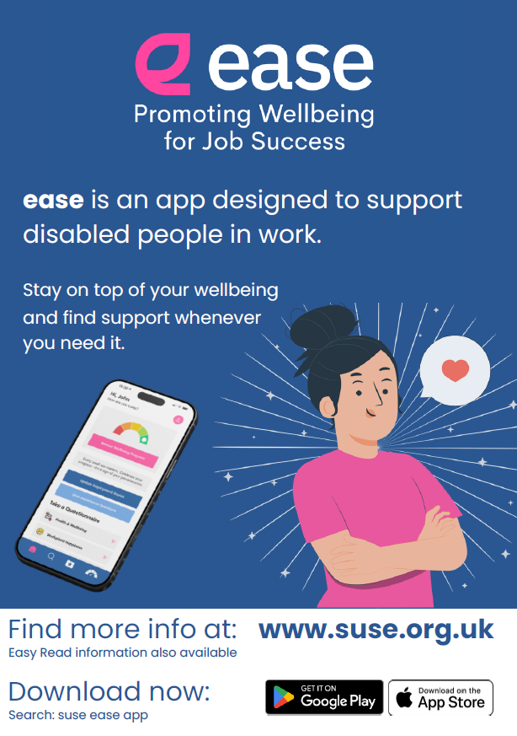
Alt text: Ease promoting wellbeing for job success. Ease is an app designed to support disabled people in work. Stay on top of your wellbeing and find support whenever you need it. Find out more at www.suse.org.uk. Easy Read information also available. Download now. Get it on Google Play and the Apple App Store. Search suse ease app. There are two images, one of a mobile phone with the screen showing the ease app, the other is an illustration of a person smiling with a speech bubble with a love heart in it.

